Explore the Design of Scaffolding Used in Well-Structured Problems

Jiayi Zhang

Teachers College Columbia University

[Jz2655@tc.columbia.edu](mailto:Jz2655@tc.columbia.edu)

The purpose of this study is to explore the use of scaffolding problems on student’s academic performance. Through analyzing and visualizing student’s behavioral data on answering scaffolded questions, I’m hoping to shed a light on issues regarding the design of scaffolding questions. Learning analytics techniques were incorporated to serve as a mean to examine the research question, while at the same time to work as an example to demonstrate a cost efficient way to analyze educational theories.

1. INTRODUCTION

1.1. WHAT IS SCAFFOLDING?

Historically, scaffolding is used by parents, teachers or more knowledgeable others as a method to provide assistance though communication to guide children to solve problems that beyond their capability (Wood 1976). Vygotsky’s Zone of Proximal Development acknowledged this phenomenon in childhood development. He describes the zone of proximal development as “the distance between the actual developmental level as determined by independent problem solving and the level of potential development as determined through problem solving under adult guidance, or in collaboration with more capable peers” (Vygotsky 1978).

Scaffolding is a teaching strategy that aims to solve the “distance” problem that described by Vygotsky. Scaffolding, along with modeling, coaching, articulation, reflection, and exploration are 6 teaching methods developed based on cognitive apprenticeship theory, that focus on closing the gap between the potential and actual development through “guided experience on cognitive and metacognitive skills and processes” (Collins, Brown and Newman 1988)

As educators and researchers have come to understand more about scaffolding, they found that the process of conducting and completing a scaffolding activity is more important than its format. Therefore, while decades ago scaffolding was viewed as a social activity that was exclusive to human interaction, it is now more broadly defined. Researchers have extended its definition to include any type of support, human or technological, that offers a guided and need-based process or experience. (Puntambekar & Hubscher 2005). E-learning, for one, utilizes scaffolding, where pre-programmed supports are provided for both well- and ill-structured problems when students feel lost. Scaffolding, particularly in this format, requires student’s active participation when guidance is provided. However, guidance and support will be and should be slowly removed as students excel on the skills. Guzdial (1994) names this process “fading”. He believes the real expertise is achieved only when students are able to exemplify their problem solving ability independently, and without assistance.

1.2. WHEN AND HOW TO SCAFFOLD?

Scaffolding has been commonly used in homework practices to facilitate the development of student’s domain knowledge as well as problem solving ability. Questions asked on homework practices tend to be well-structured problems. Contrary to open-ended, ill-structured problems, well-structured problems are domain specific. They often have a singular solution, and have limited number of rules that can be applied to the problem. Solving these questions needs both declarative knowledge such as facts and theories, and procedural knowledge such as the steps needed to solve a problem (Hong 1998)

When scaffolding is used to instruct a well-structured problem, the goal is to decompose the complex question into smaller chunks or sub-problems, in order to simplify the problem solving process. Typically, each sub-problem contains less knowledge components than the original question, so that it is small enough to suggest an obvious answer (Polson and Jeffries 1985).

1.3. WHY SCAFFOLD?

In Razzaq and Heffernan (2006) study, they raised a question; comparing using hints to completing scaffolding questions too see which gets students to learn more. Particularly they analyzed 174 middle school students’ performance on solving slope questions. By dropping students who got both of the pre-test questions right, student’s knowledge level in both hint-using and scaffold-using groups was assured at the same level. The results showed that, students in the scaffold-using group did significantly better on the harder pre-test question in the post-test. However, no significant improvement was found on the easier pre-test question, or when all the four post-test items were considered altogether. They attributed the improved performance in the scaffolding group to their active participation and the longer time that they spent on each question. However, the discrepancy of the effectiveness of scaffolding on easier and harder questions was not further analyzed.

Despite its wide use and its beneficial effect, studies on the design of scaffolding problems are incomplete. Researches on scaffolding design are diverse, but mainly focus on the social aspect of scaffolding (Vygotsky 1978), and scaffolding in ill-structured tasks (Lave and Wenger 1991). Questions like what type of knowledge or how many knowledge components each scaffolding problem should ask or include is seldom studied. Therefore in this study, by examining existing data, I want to see how students respond to slightly different scaffolding designs on well-structured problems, and hope to find an optimum scaffolding style that promotes student’s performance the best.

Particularly, I explored the following two questions in the study.

1. Do students perform differently on answering scaffolding problems that are broken down from simple or complex questions?
2. Does sequence or combination of skills in scaffolding problems influence student’s achievement?

2. METHODS

2.1. PARTICIPANTS

The dataset analyzed in this study is derived from ASSISTment 2009- 2010 Non Skill-Builder data. ASSISTment is an online intelligent tutoring system created in 2004 by Dr. Heffernan and his colleagues, aiming to provide helps to students and give immediate feedback to teachers (Feng, Heffernan and Koeginder, 2009).

Help in the system comes in two ways – hints and scaffolding problems. Particularly, if a student gets a question wrong, he can choose either to get hints, or for the system to break the question into steps. Scaffolding problems are only available on certain questions. Due to simplicity concerns, one school’s data was selected randomly for this study. For consistency, questions that contain 3 scaffolding problems were used. 492 students completed at least one such question in this school, and their action data that consists of 9576 data points was analyzed.

2.2. DATA PROCESSING

2.2.1. Features

* ASSISTment_id: the id of ASSISTment question. In this study, each set of ASSISTment question includes one main question and 3 scaffolding problems.
* Problem_id: Each main question is labeled as item 1, and scaffolding problem1 to 3 was recoded as item 2 to 4 respectively. Scaffolding problems were given in the same order in each question. Which means, the same scaffolding problems would be at the same position in each question.
* Skill_pattern: A new variable, “skill pattern”, is created based on the “skill id” from the original dataset. Letters were used to recode the numeric value in skill id to represent the pattern in each question. For example, if a main question consists of only one skill, this main question would be coded as “A”, whereas, if a main question possesses 2 skills, it would be coded as “AB”. Because scaffolding problems cannot break a single skill question any further, therefore single skill questions along with their scaffolding problems were all coded as “A-A-A-A”. However, if a main question tests on two skills, and the first two scaffolding problems test on the first skill, while the third scaffold tests on the second skill, the skill pattern for this set of questions would be “AB-A-A-B”. It’s important to note that the categorization (for example, questions categorized within skill pattern AB-A-A-B) is based on the pattern of skillset within each set of question. Therefore, each category does not necessarily represent questions that entail the same skillset. In other words, a question asked about algebra can be categorized with a geometry question as long as the skill pattern of these sets of questions is the same. 28 different patterns were identified. However, since questions are not evenly distributed in each category, only patterns that include more than 5 ASSISTment questions were analyzed and visualized.
* Skill_number: In order to see if the strategy of breaking questions into the simplest chunks works effectively for both easy and hard questions, I selected ASSISTment questions that have the simplest scaffolding problems. In other words, each scaffold in this type of question only tests on one skill from the main question’s skillset. I then separated them by the number of skills the main question has. Therefore, all “A-A-A-A” are in the same category, denoted as 1-1-1-1; whereas, AB-A-A-B was classified along with AB-A-B-B, AB-B-B-A, and 3 other patterns as 2-1-1-1. Same for the questions with 3 skills.
* Correct: The dependent variable, which demonstrates whether students get the question or problem right on the first attempt.

2.2.2. Software

The analysis was primarily conducted in RStudio. Package **dplyr** and **ggplot2** were installed for the data manipulation and visualization purposes (see Appendix for code).

3. RESULTS

3.1. SKILL NUMBER

Students’ responses were first grouped by the skill_number, then by the ASSISTment_id, and finally grouped by the problem_id. Percentage of correct was calculated in each group. This step is to check the homogeneity of student’s performance within each group (Figure 1). The percentage correct is further aggregated based on the skill_number, regardless the ASSISSTment_id. Additionally, standard deviation and standard error were computed (Table 1). A line with standard error bars was plotted for each group (Figure 2).

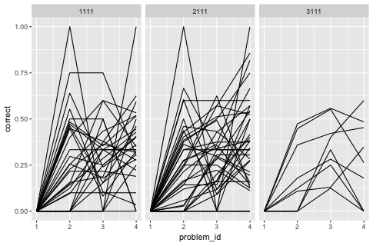

*Figure 1*. Homogeneity in 1-, 2-, 3 skills groups

Table 1. *Aggregated Percentage of Correct on Skill_number*

|  |  |  |  |  |  |
| --- | --- | --- | --- | --- | --- |
| Skill_number | Problem_id | Percent of Correct | Stv. | N | Standard Err |
| 1-1-1-1 | 1 | 0.000 | 0.00 | 746 | 0.000 |
| 1-1-1-1 | 2 | 0.338 | 0.47 | 746 | 0.017 |
| 1-1-1-1 | 3 | 0.281 | 0.45 | 746 | 0.016 |
| 1-1-1-1 | 4 | 0.329 | 0.47 | 746 | 0.017 |
| 2-1-1-1 | 1 | 0.000 | 0.00 | 811 | 0.000 |
| 2-1-1-1 | 2 | 0.299 | 0.46 | 811 | 0.016 |
| 2-1-1-1 | 3 | 0.322 | 0.47 | 811 | 0.016 |
| 2-1-1-1 | 4 | 0.356 | 0.48 | 811 | 0.017 |
| 3-1-1-1 | 1 | 0.000 | 0.00 | 309 | 0.000 |
| 3-1-1-1 | 2 | 0.317 | 0.466 | 309 | 0.027 |
| 3-1-1-1 | 3 | 0.404 | 0.49 | 309 | 0.028 |
| 3-1-1-1 | 4 | 0.359 | 0.48 | 309 | 0.027 |

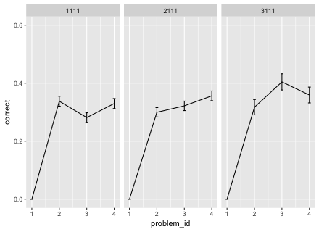

*Figure 2*. Aggregated Line Graph on Skill_number

From the aggregated line graph presented above, regardless of how many skills a main question asks, the accuracy on each scaffolding problem reached to at least 25%. Which means that these scaffolding problems to some extend simplified the question, which could have potentially facilitated learning. However, the performance on the scaffolds varies among the 3 groups, which is demonstrated by the different shape of the three lines. The line in the first panel shows student’s performance with repeated practice on the same skill in both the main question and scaffolding problems. Student’s performance increased by 33% after practiced on the 1st scaffolding problem. The percentage of correct maintained at 33% after they completed all 3 scaffolding problems. This pattern may indicate that, when students are doing questions that have only one skill, repeated practice on the same skill in the scaffolding problems may not yield better performance.

In the second panel, student’s performance gradually increased throughout the practice session. Two skills were practiced either alternatively or one of the skills was practiced repetitively. More will be discussed later in the skill pattern section. Compared to the first two groups, the biggest change in performance is in the 3-skills-group, in which 3 skills were practiced individually. Specifically, the accuracy on the second scaffolding problem is significantly higher than the percentage correct on first scaffolding problem. Inferences and applications of using scaffolding on easy and more complex questions are discussed in the next section.

3.2. SKILL PATTERN

2-skills-group that mentioned above was further separated into sub-groups based on the skill-pattern.7 patterns were identified initially, but since some of the patterns do not have enough variation in questions to draw a conclusion from, only 4 different patterns that each has more than 5 ASSISTment questions, were analyzed and visualized (see figure 3). Later, the lines were aggregated within each pattern (see figure 4).

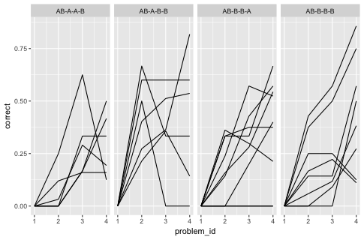

*Figure 3*. Skill Pattern from 2-Skills-Group

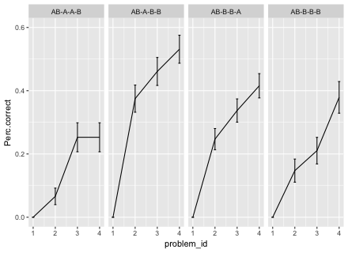

*Figure 4*. Aggregated Line Graph on Skill Pattern from 2-Skills-Group

From graph 4, regardless the type of skill pattern, compared to main questions, student’s performance on scaffolding problems increased dramatically in all four scenarios. However, it is fairly difficult to conclude which type of practice yield the best result, since improvement is not consistent and not significantly different from one another. Therefore, a more comprehensive analysis that consists of more types of skill pattern is needed.

4. DISCUSSION

As stated at the beginning, the purpose of this study is to explore, understand, and testify the effect of scaffolding on student’s academic performance by using existing data and employing learning analytics methods. We found that scaffolding problems in the analyzed dataset did serve the purpose of simplifying the original questions. This result is exemplified by the improved accuracy on each scaffolding problem compared to its main question. Furthermore, similar to the previous study’s findings, students tend to benefit more when doing scaffolding problems from more complex questions compared to easier questions. Specifically, in this study, when doing simple questions that have only one skill, student’s performance remained at the same level after 3-repeated practice on scaffolding problems. In the 2-skills panel, even though the performance gradually increased over time, the changes were not significant.

However, in more complex questions that have 3 skills, the drastic change in performance between the first and the second scaffold could infer that the success on the 1st scaffold was carried on to the second scaffolding problem. From comparing these three lines, it seems like the effect of scaffolding would be most utilized when it is applied to more complex questions. Again, this result align with the Razzaq and Heffernan’s (2006) finding that students tend to benefit more from doing scaffolding problems when the questions are more complex. In addition, our study suggested that transfer of learning could be a potential reason that causes the discrepancy of the effectiveness of scaffolding on easy and hard questions. However, a more precise analysis is required to confirm this hypothesis.

Due to the exploratory nature of the study, the study design is not impeccable. Therefore, several recommendations are suggested for future study’s reference.

First, student’s performance on the following question should be considered. Specifically, data about whether a student gets the same question correct the next time after practice on the scaffolding problems should be included. This performance on the following question can be used as a better indicator to test the effectiveness of scaffolding and its design.

One of the research questions asked at the beginning was trying to understand how to best utilize scaffolding experience by testing right amount of knowledge components in each scaffold. So that students would not feel discouraged by answering complex scaffolding problems or feel bored by doing scaffolding problems that are too simple, but at the same time they would still have a chance to practice on both declarative knowledge (test by single skill scaffolds) and procedural knowledge (scaffolding problems that test on multiple skills). However, due to limited variation in the dataset, I was unable to analyze questions that have scaffolding problems that test on multiple skills, such as questions with skill pattern of “AB-A-B-AB” or “AB-AB-AB-AB”. Therefore, expanding the sample size and diversifying the question types should be considered in the future studies.

5. REFERENCES

Collins, A., Brown, J. S., AND Newman, S. E. 1988. Cognitive apprenticeship: Teaching

the craft of reading, writing and mathematics. *Thinking: The Journal of Philosophy for Children*, *8*(1), 2-10.

Feng, M., Heffernan, N., AND Koedinger, K. 2009. Addressing the assessment challenge

with an online system that tutors as it assesses. *User Modeling and User-Adapted Interaction*, *19*(3), 243-266.

Guzdial, M. 1994. Software‐realized scaffolding to facilitate programming for science

learning. *Interactive Learning Environments*, *4*(1), 001-044.

Hong, N. S. 1998. The relationship between well-structured and ill-structured problem

solving in multimedia simulation.

Lave, J., AND Wenger, E. 1991. *Situated learning: Legitimate peripheral participation*.

Cambridge university press.

Poison, P. G., AND Jeffries, R. 2014. Instruction in general problem-solving skills: An

analysis of four approaches. *Thinking and Learning Skills: Volume 1: Relating Instruction To Research*, 417.

Puntambekar, S., AND Hubscher, R. 2005. Tools for scaffolding students in a complex

learning environment: What have we gained and what have we missed?. *Educational psychologist*, *40*(1), 1-12.

Razzaq, L., AND Heffernan, N. 2006. Scaffolding vs. hints in the Assistment System. In

*Intelligent Tutoring Systems* (pp. 635-644). Springer Berlin/Heidelberg.

Wood, D., Bruner, J. S., AND Ross, G. 1976. The Role Of Tutoring In Problem Solving.

*Journal of Child Psychology and Psychiatry*, 17(2), 89-100

Vygotsky, L. 1978. Interaction between learning and development. *Readings on the*

*development of children*, *23*(3), 34-41.